CC_PRS_1 - Update personal information (Done by:Anisa Domi)
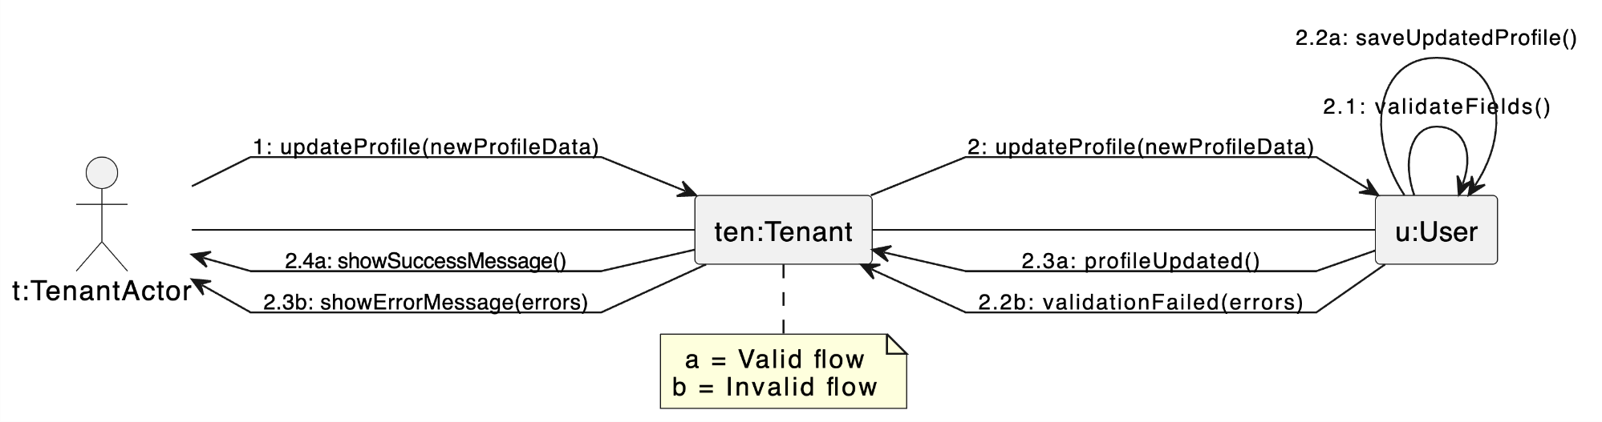

CC_PRS_2 - Search properties (Done by:Anisa Domi)

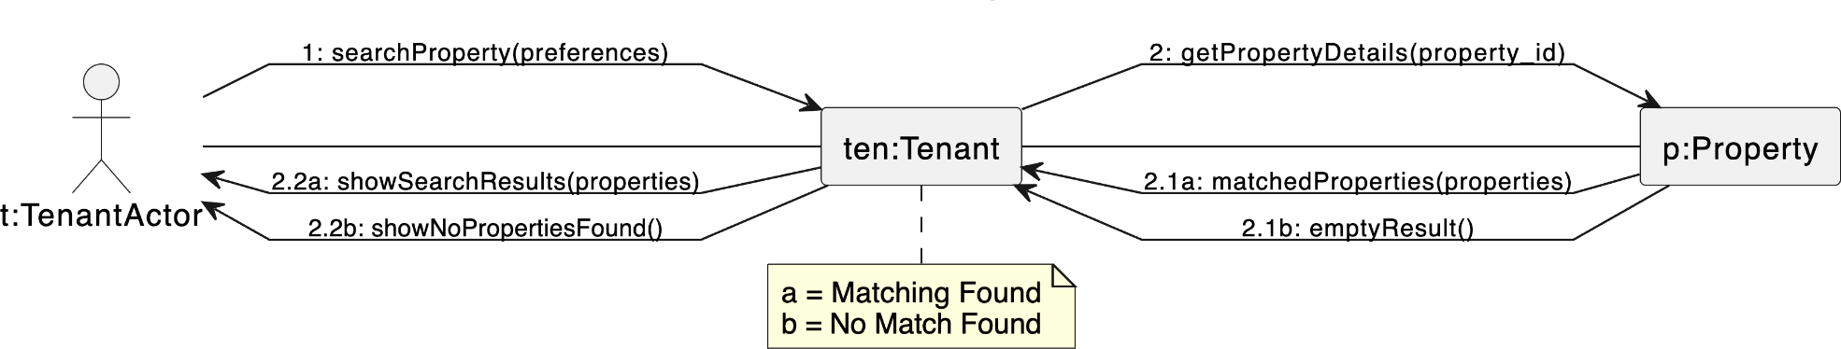

CC_PRS_3 - Filter properties (Done by:Anisa Domi)

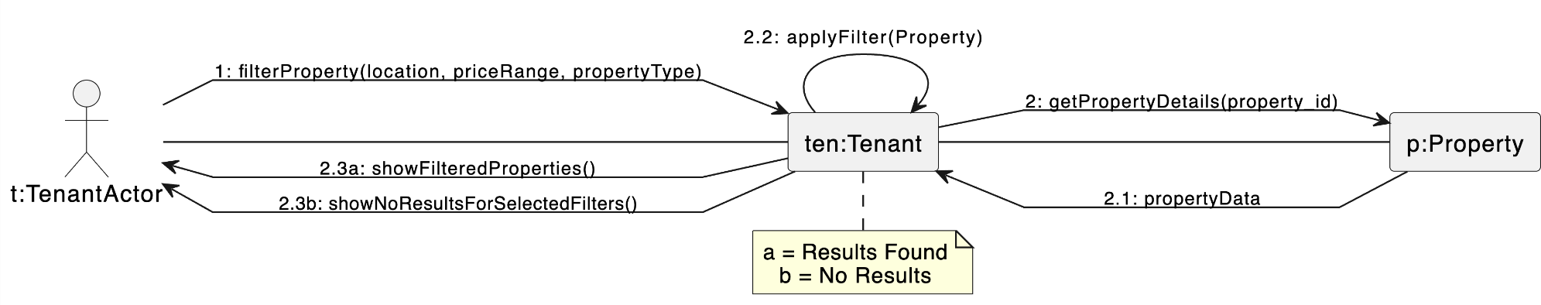

CC_PRS_4 - View property details and booking history (Done by:Anisa Domi)
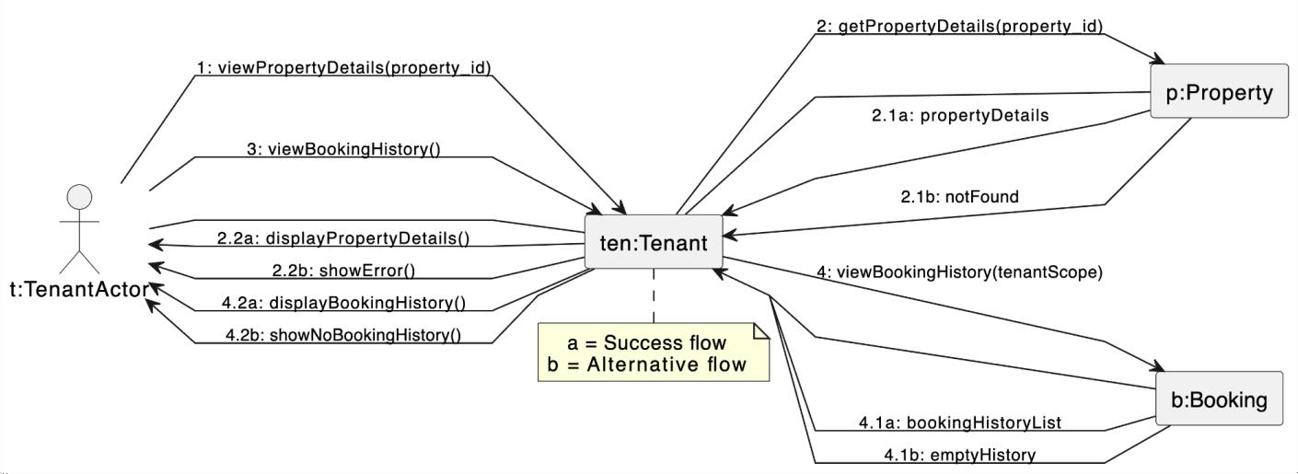

CC_PRS_5 - Send rental requests and message to property owners (Done by:Anisa Domi)

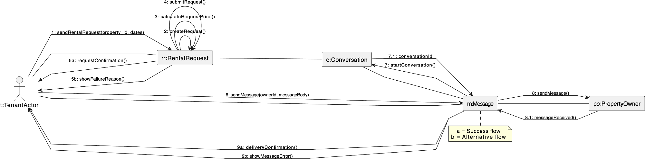

CC_PRS_6 - Cancel rental request (Done by:Anisa Domi)

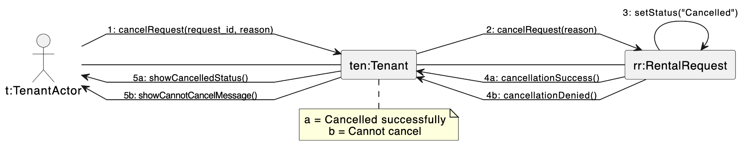

CC_PRS_7-Receive Messages from property owners (Done by: Haidi Toto)
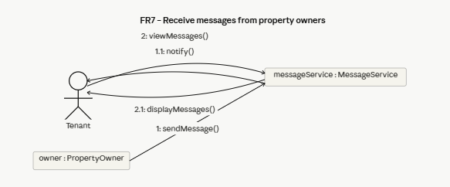

CC_PRS_8 – Submit Rental Payment (Done by: Haidi Toto)
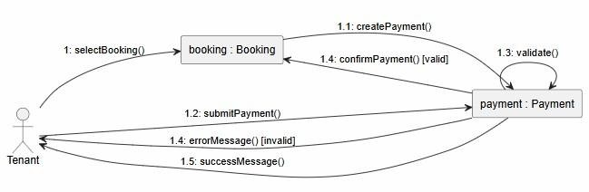
CC_PRS_9 – Save Favourite Properties for later viewing (Done by: Haidi Toto)
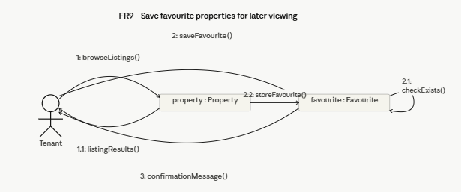

CC_PRS_10 – Review and Rate Property (Done by: Haidi Toto)
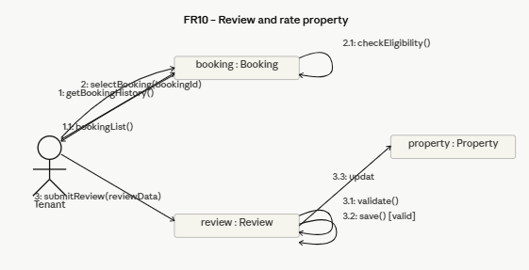
CC_PRS_11 – Update Profile information and Availability of Rental Properties (Done by: Haidi Toto)
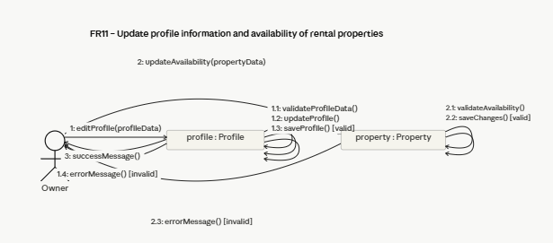
CC_PRS_12 – Add Property Listing (Done by: Haidi Toto)
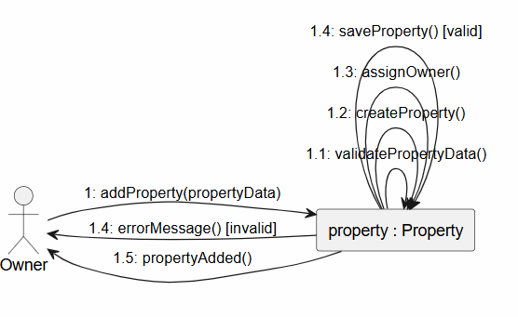

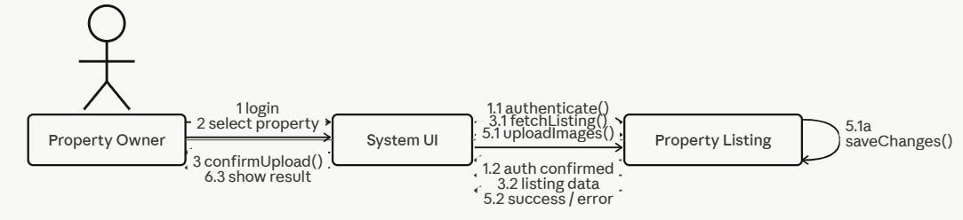
CC_PRS_13-Upload Property Images (Done by: Ledio Tafciu)

CC_PRS_14 - Edit Property Listing (Done by: Ledio Tafciu)
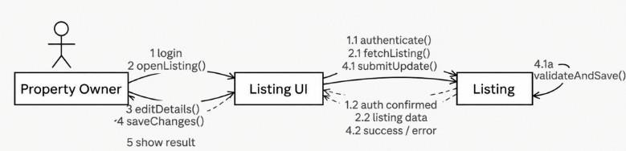
CC_PRS_15 - Delete Property Listing (Done by: Ledio Tafciu)
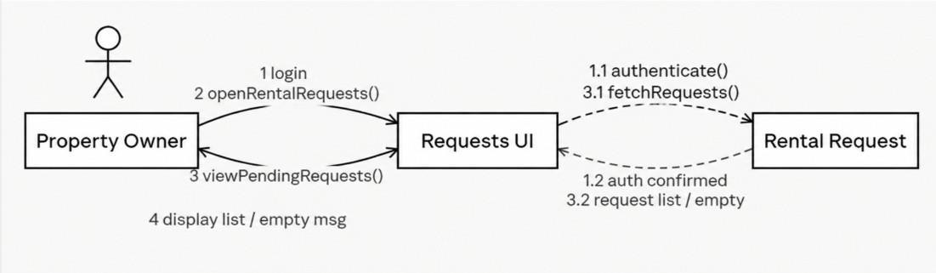
CC_PRS_16 - View Rental Requests (Done by: Ledio Tafciu)
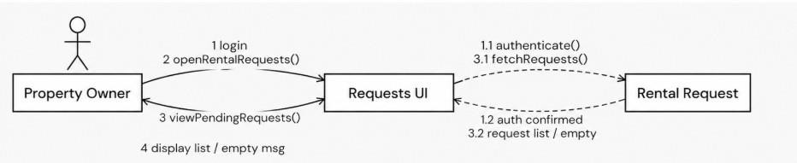

CC_PRS_17 - Accept or Reject Rental Request (Done by: Ledio Tafciu)
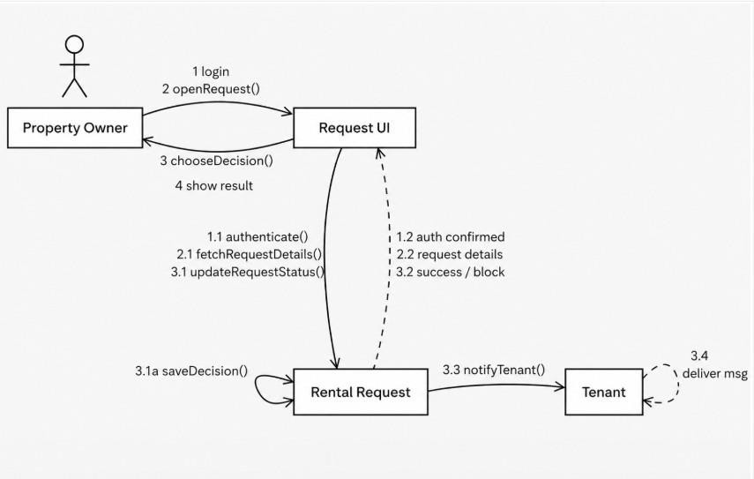
CC_PRS_18 - Send Message To Tenant (Done by: Ledio Tafciu)
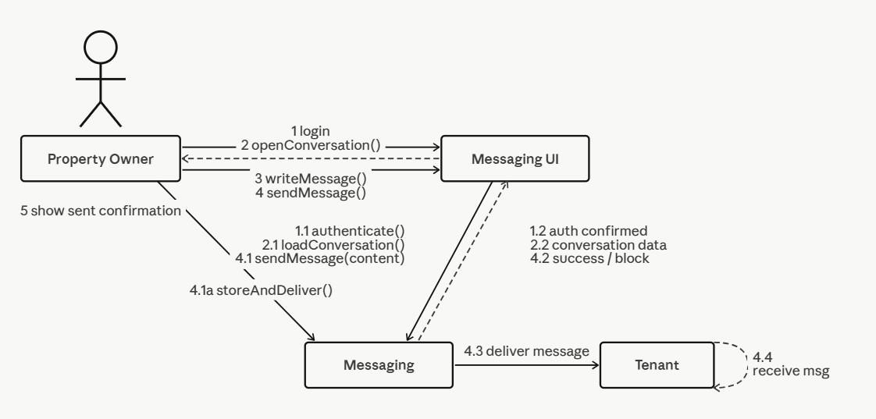

CC_PRS_19 - View Booking History (Done by:Desard Lybeshari)
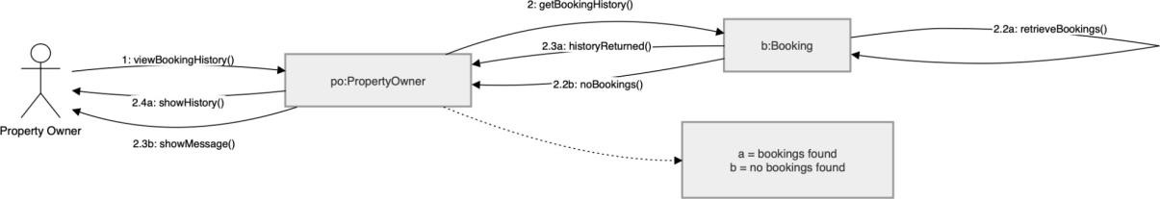

CC_PRS_20 - Mark Property as Unavailable or Rented (Done by:Desard Lybeshari)

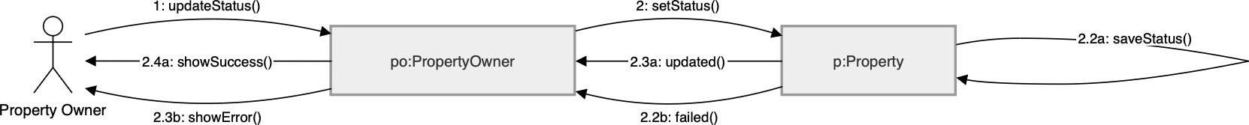

CC_PRS_21 - Edit User Accounts (Done by:Desard Lybeshari)
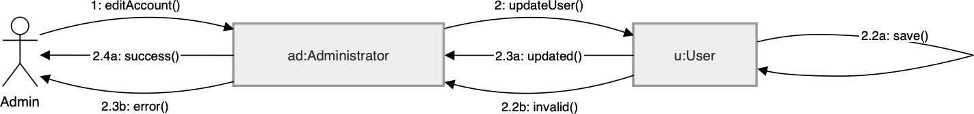

CC_PRS_22 - Delete User Accounts (Done by:Desard Lybeshari)
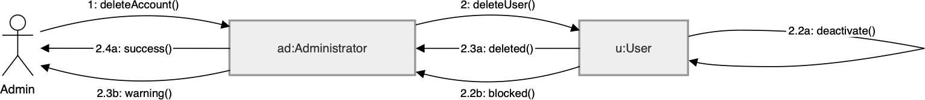

CC_PRS_23 - Monitor Rental Transactions (Done by:Desard Lybeshari)

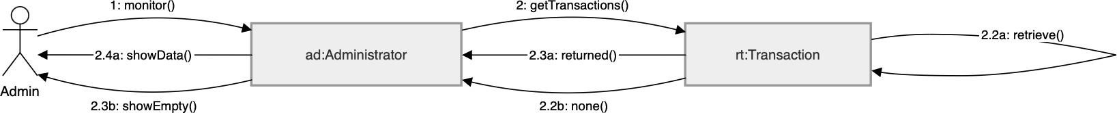

CC_PRS_24 - View System Reports and Property Listings (Done by:Desard Lybeshari)

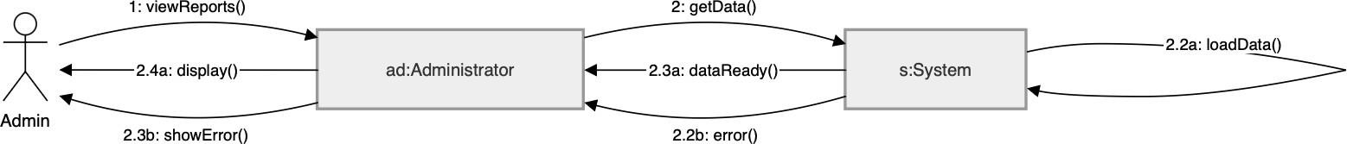

CC_PRS_25- Remove inappropriate listings (Done by:Matias Bali)
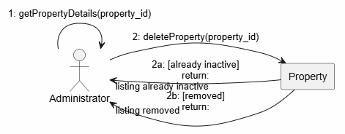

CC_PRS_26- Manage disputes & system settings (Done by:Matias Bali)
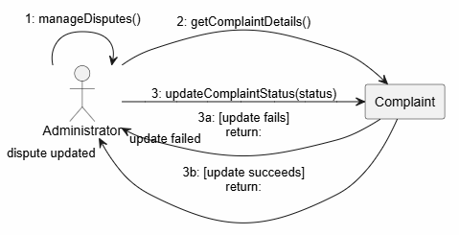

CC_PRS_27- Restore user accounts (Done by:Matias Bali)
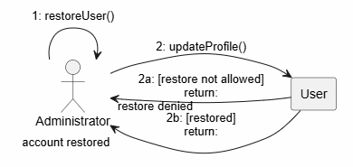

CC_PRS_28- Suspend user accounts (Done by:Matias Bali)
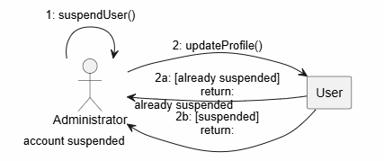

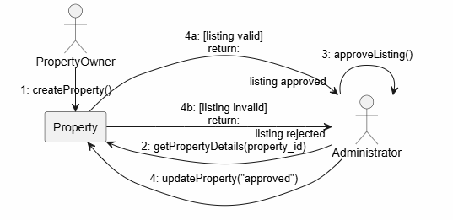
CC_PRS_29- Verify and Approve property listings (Done by:Matias Bali)

CC_PRS_30- Monitor rental requests (Done by:Matias Bali)
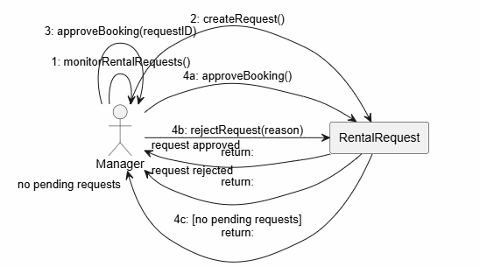

CC_PRS_31 – Generate Management Reports (Done by: Ornelt Lemellari)
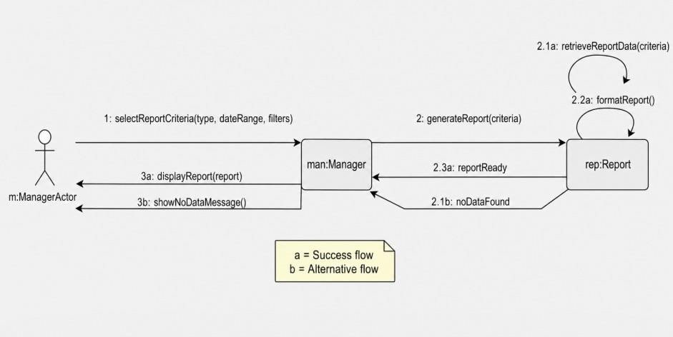

CC_PRS_32 – Approve Large Discounts (Done by: Ornelt Lemellari)
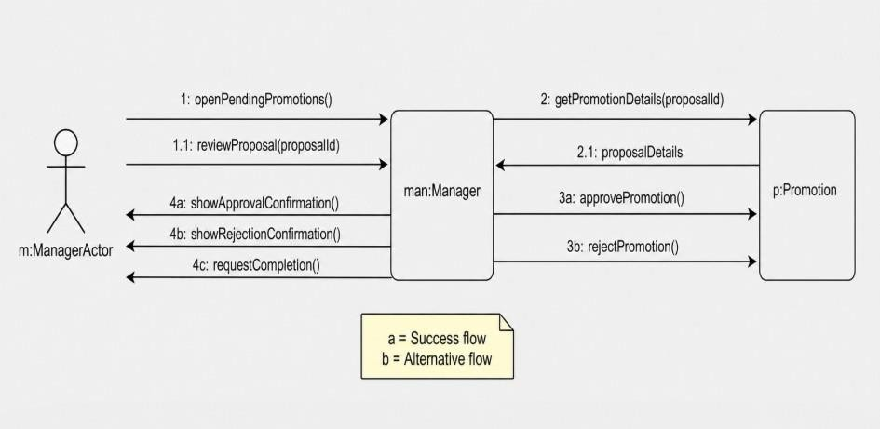

CC_PRS_33 – Review Complaints and forward unresolved issues (Done by: Ornelt Lemellari)
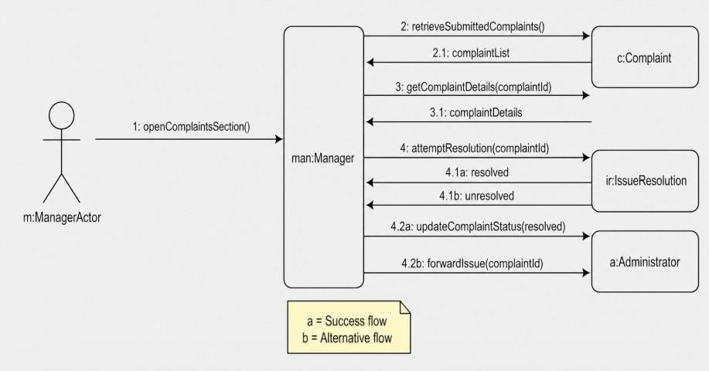

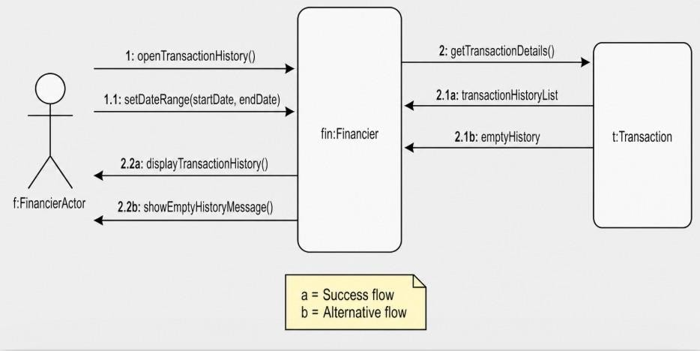
CC_PRS_34 – View Transaction History (Done by: Ornelt Lemellari)

CC_PRS_35 – Monitor Payment process and Security (Done by: Ornelt Lemellari)
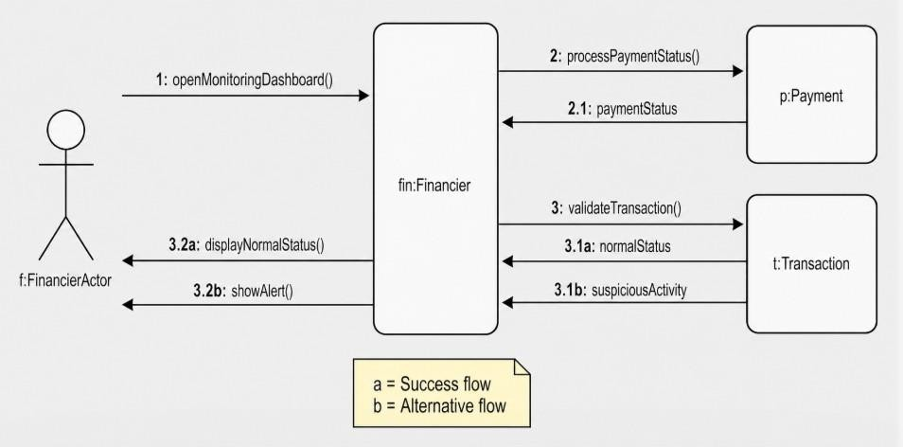

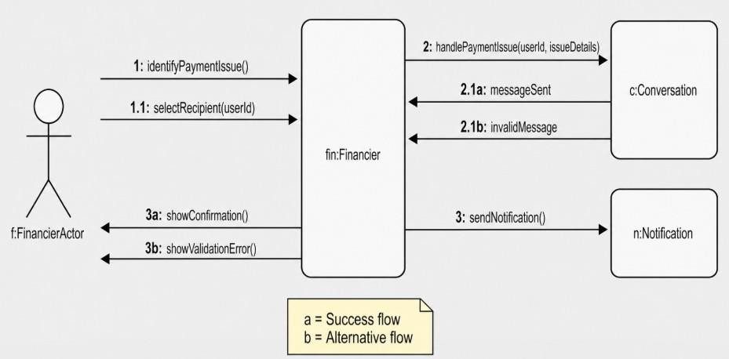
CC_PRS_36 – Communicate Payment Issues with tenants and owners (Done by: Ornelt Lemellari)

CC_PRS_37- Approve refunds for cancelled rental transactions (Done by:Kevin Muho)
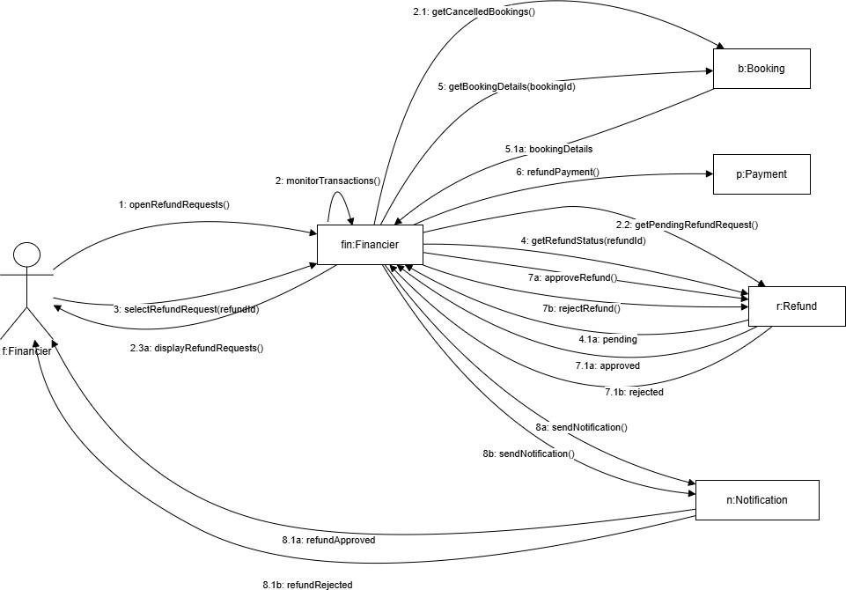

CC_PRS_38- Manage Complaints (Done by: Kevin Muho)

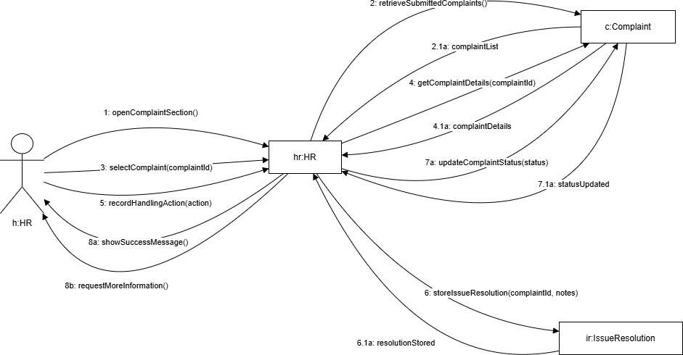

CC_PRS_39- Send notifications and reminders (Done by:Kevin Muho)
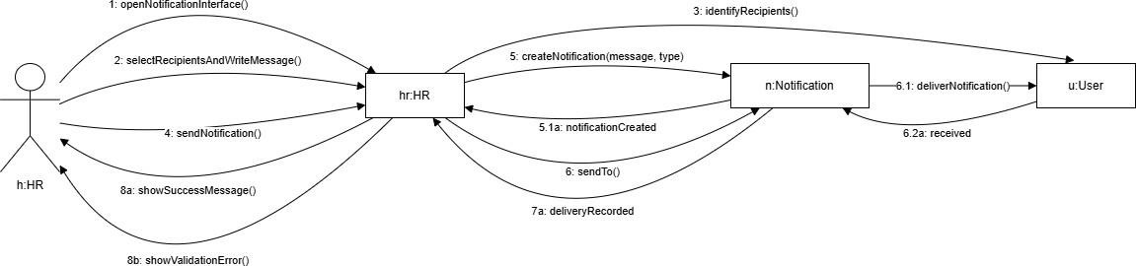

CC_PRS_40- Maintain Record of User Issues and Resolutions (Done by:Kevin Muho)

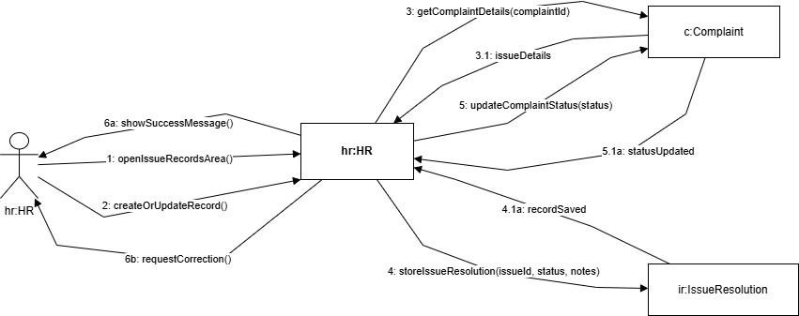

CC_PRS_41- Register Account (Done by:Kevin Muho)

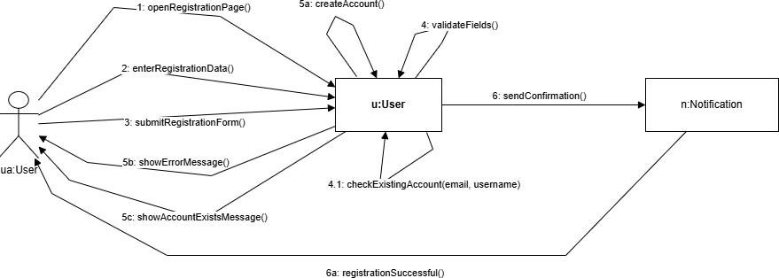

CC_PRS_42 - Log In (Done by:Kevin Muho)
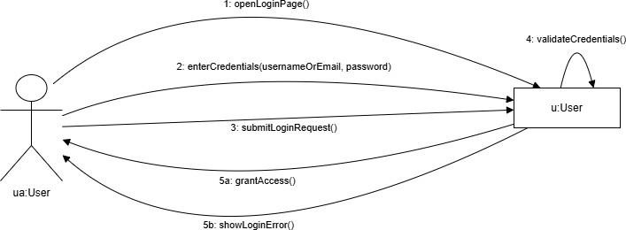

CC_PRS_43 – Log Out (Done by:Kevin Muho)
